Chapter 6: Systems of Inequalities

6.4 – Systems of Inequalities

SKETCHING THE GRAPH OF AN INEQUALITY IN TWO VARIABLES

1. Replace the inequality sign by an equal sign, and sketch the graph of the resulting equation.
(Use a dashed line for < or > and a solid line for $≤$ or $≥$.)

2. Test one point in each of the regions formed by the graph in Step 1. If the point satisfies the
inequality, shade the entire region to denote that every point in the region satisfies the
inequality.

Example 1: Sketch the graph of $y≥x^{2}-1$.

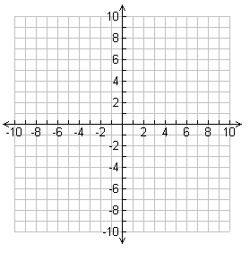

The inequality in this example is a nonlinear inequality in two variables.

Example 2: Sketch the graph of each linear inequality below.

$x>-2$ $y≤3$

Example 3: Sketch the graph of $x-y<2$.

SYSTEMS OF INEQUALITIES
Many practical problems in business, science, and engineering involve systems of linear inequalities. A solution of a system of inequalities in $x$ and $y$ is a point $(x, y)$ that satisfies each inequality in the system.

Example 4: Solving a System of Inequalities
Sketch the graph (and label the vertices) of the solution set of the system.
$$x-y<2$$
$$x>-2$$
$y≤3$

-----------------------------------------------------------------------------------------------------------------------------
Example 5: Sketch the region containing all points that satisfy the system. $\begin{matrix} x^{2}-y≤1 \\ -x+y≤1\end{matrix}$

When solving a system of inequalities, you should be aware that the system might have
no solution.

Example 6: Sketch the region containing all points that satisfy the following system.
$$x+y>3$$
$$x+y<-1$$

-----------------------------------------------------------------------------------------------------------------------------
Another possibility is that the solution set of a system of inequalities can be unbounded.
Example 7: Sketch the region containing all points that satisfy the following system.
$x+y<3$
$$x+2y>3$$

Name ____________________________________ Date___________________________
Advanced Algebra Homework

Part I: Graph the following inequalities on the coordinate plane below.

1. Graph $y≥2x-3$ 2. Graph $3x+2y<6$

Part II: Solve the following system of equations.
3. $y>x^{2}$
$x<y+2$

